**Final Year Project**

**Marketing Plan of Silk Towel Tissues**

**[](http://www.google.com.pk/imgres?imgurl=http://www.nasirpk.20m.com/NU%20Logo.jpg&imgrefurl=http://www.nasirpk.20m.com/FAST-NU.htm&usg=__LwRfLAvLTZ1c-BtRyqKVCd97iqk=&h=435&w=450&sz=60&hl=en&start=1&zoom=1&tbnid=TpoqXBfsuTTLHM:&tbnh=123&tbnw=127&ei=RYvgTsLLJMf-4QTGsYztCQ&prev=/search?q=fast+nu+logo&hl=en&gbv=2&tbm=isch&itbs=1)**

**Advisor**

Ms. Fatima Saman Qaiser

**Group Members**

Jamshaid Akram 09-5498

Musa Khan 09-5495

Rizwan Ghumman 08-0842

Sarmad Razzaq 09-5496

**June 9, 2012**

CONTENTS

Acknowledgment 5

Executive Summary 6

Introduction 7

SWOT Analysis 9

Strengths 9

Weaknesses 9

Opportunities 10

Threats 10

Factor Analysis 11

Internal Factor Analysis 11

External Factor Analysis 12

Why Towel Tissues? 14

Benefits of the Product 14

• Alternative to Messy Towels 15

• Fast Hand-Drying 15

• Choice of Standard Towels 15

• New Interleaved Food Hygiene Hand Towel 15

• Beneficial Product 15

• Future Opportunities 16

• Size, Design and Packing 16

Marketing Plan 16

Environmental Analysis (Situational Analysis) 17

Competitive Forces 17

Economic Forces 17

Legal and Regulatory Forces 18

Technological Forces 18

Socio Cultural Forces 18

Target Markets 20

Identifying the Segment 20

Segmentation 20

Marketing Mix 22

Current marketing objectives and performance 22

Marketing Objectives 22

Marketing Analysis 22

Product Strategies 24

Name 24

Overview of Tissue Paper products 24

Pricing Strategy 24

Distribution Strategy 25

Channels 25

Promotional Strategy 26

Website 27

Promotion on Electronic media 30

Positioning 31

Tag line 31

Placement 31

Sales Plan 31

Timeline 32

Financial Plan 32

Initial Funding 32

Expected Sales 34

Breakeven Point 34

Five year income statement: 36

Media Plan and Budget Allocation 37

CONCLUSION 39

Bibliography 40

Appendix 41

Questionnaire for Silk Towel Tissue 41

Pie Charts for the responses to the questionnaires 43

**TABLE OF FIGURES**

Figure 1: Channels 27

Figure 3: Budget Advertising 39

Figure 4: Yearly Budget 40

Table 1: Internal Factor Analysis 13

Table 2: External Factor Analysis 14

Table 3: Marketing Objectives 28

Table 4: Timeline 33

Table 5: Initial Funding 34

Table 6: Variable Expense 34

Table 7: Breakeven Point 36

# Acknowledgment

First of all, we are really thankful to Almighty Allah, the most Beneficent, the most Merciful and the Glorious of all, with the grace of whom, our project has reached to a successful end. This is to acknowledge that the report made could not be possible without the endless efforts of all the group members.

We would like to thank our friends who helped us throughout the way. We are specially thankful to “Ms. Fatima Saman Qaiser**”**who helped us in our project, without her guidance and aid we were unable to complete our project and that is why we are dedicating this report to her with a pray, that may Allah bless us with such a great and cooperative teachers in our future life.

# Executive Summary

Silk is manufacturing towel tissue product to reach its customers. Now Pakistan is self–sufficient in tissue paper manufacturing and it is also exporting tissue paper to the other countries like Afghanistan, Iran, and Middle Eastern countries. Tissue paper is now a part of life style especially in urban areas of Pakistan. There are very few firms competing in tissue paper industry namely Packages, Flying, Fay, Jasmine and Movita. Silk believes that the orientation towards time, concern about health and convenience has resulted in increased demand for tissue papers since it was first introduced in 1981 among the consumer market. Silk is to launch a new product “Silk Towel Tissues”with an aim to become the market leader in future in the towel tissue industry. To serve the market needs in a way to personify cleanliness in the daily lives of the consumers with convenient hygiene product is the basic goal of our business. Orientation towards time, concern for health and convenience has resulted in increased demand for tissue paper since it was first introduced in 1981. A towel tissue that we are introducing is a viable product. After analyzing all aspects of our existing products and market situation we found that it’s the best time to launch towel tissues. There is a gap in the market and in order to fill that gap we are introducing this product. In our opinion it has a lot of benefits for customer. The initial funding required for the project in not very huge. Today people are more health conscious as compared to the past. T.V ads and research work on hygienic conditions made them more health and convenience conscious. Increasing rate of population is an opportunity for industry to grow. Pollution rate is also high in Pakistan that effect skin, so people use tissue paper for caring their skin. Initially Lahore will be our focus and Towel tissues will be placed at main retail outlets and departmental stores as people are aware of silk towel tissue.

# Introduction

Silk towel tissues one and first of its kind is going to launch its product with the start of next year. We are basically targeting the upper middle and upper class to provide them with the best quality towel tissues which are made keeping in mind our customers’ daily requirements and hygiene issues. To serve the market needs in a way to personify cleanliness in the daily lives of the consumers with convenient hygiene product is the basic goal of our business. Orientation towards time, concern for health and convenience has resulted in increased demand for tissue paper since it was first introduced in 1981.

We will launch our product initially by giving free samples to people in big malls and shopping centers and then by running campaigns for creating awareness among people about our product and its value in their lives. Firstly, we will launch this product in urban areas of Lahore and if became successful, we will launch throughout Pakistan. When launching a new product Silk have to keep in mind the competitive forces and their reaction toward the new product launch. There are very few firms competing with Silk. Amongst all the firms in the tissue paper industry, three main competitors are: Flying Tissues, Packages and Fay Tissues. A towel tissue that we are introducing is a viable product. After analyzing all aspects of our existing products and market situation we found that it’s the best time to launch towel tissues. There is a gap in the market and in order to fill that gap we are introducing this product. In our opinion it has a lot of benefits for customer.

Our target would be the health and convenience conscious people; they can be from any age group. The other main segments which we would like to target are travelers, restaurants, hotels, airlines and sports people. Despite a poor economic situation generally, the tissue paper industry has done relatively well during this difficult period. It is maintaining a constant growth rate of 14 % as Pakistan GDP growth rate is around 3.2 any industry growing equal or more than GDP is good market growth and there is potential in that market. All these economic indicators suggest that Silk in order to stay ahead from its competitors should now launch its new product. Silk will get a strong distribution network will they have a range of channels in the different areas. We will distribute our product through large number of distributers, and retailers.

Our product has unique features that no other competitor is providing it’s the first of its kind product available in the market. The benefits that are most important are that it will replace the use of messy towels and will provide customers with an alternative.

# SWOT Analysis

Before discussing the marketing plan, discussing the internal strengths & weaknesses and external opportunities & threats is important. So, following SWOT analysis clearly defines our position in the market.

## Strengths

* Product fulfilling the needs of the customers
* Favorable access to distribution networks
* Affordable price
* Communication system is very strong among departments, using ERP

The main aim of any business is to fulfill the needs of their customers and satisfy them so our main strength is that our product fulfills the needs of customer, according to our research which is attached (Appendix ii). As we have planned to import our products so we will be doing it through distribution networks that are efficient as well as easy to access. In this time of high inflation our low prices give sigh of relief to customers.

## Weaknesses

* Dealing only in tissue making
* Employee satisfaction is weak
* Job security is less
* Being new in industry, acceptance by the people will be less

As this is our first product in market, so we are focusing only on tissue making which is our biggest weakness; in a way that we will not be able to cover our expense in initial period. Being new in industry, people are not willing to accept your brand. Then as we are importing our most of the product so sometimes there can be increase in supply or decrease leading low satisfaction for employees as they are not required to do much work.

## Opportunities

* An unfulfilled customer needs
* Growing Market 15 %
* Potential to capture additional market share
* Due to fewer competitors in the market we can flourish more

In this busy world everyone is in search of convenience and keeping this need in mind Silk fulfills their need. This market is just in its initial stages so it has growth rate of 15% so we have opportunity to capture maximum market share. Another important prospect is of having fewer competitors in market which is also positive for us.

## Threats

* Shift in consumer tastes
* Emergence of substitute product
* New government regulations
* Chinese & smuggled cheap tissue paper products
* Imported brands entry into tissue paper industry
* Environmental issues

We never know when consumer’s tastes begin to change and our product just start to become inferior good for them so this is our biggest threat but we can overcome that by providing our customers with additional features such as different colors, fragrance, improved quality. In this way we adjust our product both in economic boom as well as in inflation. When market will eventually grow to decent standard, people will start making substitutes for towel tissues. Apart from that towel tissues are made from wood and the way these tissues are used so roughly, environmentalists are strongly against it so if some day they get it banned then it can be biggest threat for this industry. By creating awareness among people and by using recycling method we can deal with this.

# Factor Analysis

To understand the internal strengths and external challenges which company has to face with the launch of new product in the market, factor analysis is done. This analysis has been done at two stages i.e. internal factor analysis (which discusses the internal strengths and weaknesses of our new product, it concerns the company and reflects its position) and external factor analysis (which discusses the opportunities and threats of our product; it concerns the environment and reflects its impact on activity of the company).

## Internal Factor Analysis

The internal factor analysis is done on the basis of assigning every strength and weakness with the due weight out of 1 and then rating each factor according to its importance for our product.

|  |  |  |  |
| --- | --- | --- | --- |
| **FACTOR** | **WEIGHT**  (How important it is for my product) | **RATE (1-4)**  (Company Rates its ability) | **TOTAL** |
| **Strengths** |  |  |  |
| Strong Financial position | 0.1 | 4 | 0.4 |
| Strong brand name | 0.1 | 3 | 0.3 |
| Good reputation among customer | 0.1 | 2 | 0.1 |
| Exclusive access to high grade natural resources | 0.05 | 2 | 0.1 |
| Favorable access to distribution networks | 0.1 | 4 | 0.4 |
| Only firm in this industry using modern technology | 0.05 | 2 | 0.1 |
| Communication system is very strong among departments, using ERP | 0.1 | 4 | 0.2 |
| Rose petal and tulip had more than 75% market share in domestic market | 0.1 | 4 | 0.4 |
| Joint ventures with big firms of the world | 0.05 | 2 | 0.1 |
| **Weakness** |  |  |  |
| Dealing only in paper packaging | 0.05 | 3 | 0.15 |
| Employee satisfaction is weak. | 0.1 | 4 | 0.4 |
| Job security is less | 0.1 | 3 | 0.3 |
| **TOTAL** | **1** |  | **2.95** |

Table 1: Internal Factor Analysis

## External Factor Analysis

The external factor analysis is done on the basis of assigning every opportunities and threats with the due weight out of 1 and then rating each factor according to its importance for our product.

|  |  |  |  |
| --- | --- | --- | --- |
| **FACTOR** | **WEIGHT**  (How important it is for my product) | **RATE (1-4)**  (Company Rates its ability) | **TOTAL** |
| **Opportunities** |  |  |  |
| An unfulfilled customer needs (health, time & environment) | 0.1 | 4 | 0.4 |
| Growing Market 15 % | 0.1 | 3 | 0.3 |
| Arrival of new technology | 0.05 | 2 | 0.1 |
| People orientation towards convenient and hygienic products | 0.1 | 2 | 0.2 |
| Very few brands in tissue paper market (Brand building) | 0.15 | 4 | 0.6 |
| **Threats** |  |  |  |
| Shift in consumer tastes, away from the firm product | 0.05 | 3 | 0.15 |
| Emergence of substitute products ( handkerchief, napkins, towels) | 0.1 | 4 | 0.4 |
| New government regulations (duties, taxes) | 0.1 | 1 | 0.1 |
| China & smuggled cheap tissue paper products | 0.15 | 3 | 0.45 |
| Imported brands entry into tissue paper industry | 0.1 | 3 | 0.3 |
| **TOTAL** | **1** |  | **3** |

Table 2: External Factor Analysis

# Why Towel Tissues?

The leading brands of tissue industry include Packages, Flying, Jasmine and Movita.(List of Companies). The tissue industry is highly concentrated and integrated with tissue converting. The top two producers account for about 85% of tissue market share in Pakistan. Orientation towards time, concern for health and convenience has resulted in increased demand for tissue paper since it was first introduced in 1981. We have chosen towel tissues because they work well in comparison to cloth towel because of the internal spaces in paper tissues which soak water inside them. Besides that they can be quite helpful to keep vegetables and fruits away from being stale because the material used in making of Silk tissues do not allow the outer moisture to enter inside and provides more protection in comparison to ordinary tissues or plastic bags.

This sector over the years has shown a constant growth rate of 14-15% (Tissues-in-Pakistan). New product development is an essential activity for companies seeking growth. After the above analysis we have suggested Silk to launch Towel Tissues as explained later in marketing research. Silk is not manufacturing any kind of product thus it should to take some help (due to personal relations with Syed Yawar Ali (CEO) of company they are willing to work with us) from the leading companies such as Packages limited that is already manufacturing tissue papers. Through this product we can identify a new market segment, increase our sales. It will be a new and novel concept in Pakistan that from now onwards hand towels would be introduced in consumer packaging.

## Benefits of the Product

A towel tissue that we are introducing is a viable product. After analyzing all aspects of our existing products and market situation we found that it’s the best time to launch towel tissues. There is a gap in the market and in order to fill that gap we are introducing this product. In our opinion it has a lot of benefits for customer, those are as under:

### Alternative to Messy Towels

Our product provides an alternative for messy and unhygienic towels with our clean paper towels.

### Fast Hand-Drying

The quality of these towels offers the best Combination of Value and absorbency.

### Choice of Standard Towels

Most of the people are conscious about the matching and contrasting colors of different products so to provide our consumers with their needs keeping in mind we are providing them with three different color choices in the towels i.e. natural white, blue and green.

### New Interleaved Food Hygiene Hand Towel

Designed specifically for use where food is prepared. The interleaved fold hand towel with high absorbency is dispensed one towel at a time; its self-presenting format helps to reduce usage costs.

### Beneficial Product

Due to convenient use and packing it’s a beneficial product for the travelers, as it won`t to occupy much space and silk towel tissue packs fits anywhere.

### Future Opportunities

In future when our product would have been launched then we can supply our towel tissues to hotels, restaurants, airlines and other institutional buyers can make use of this product to provide better value to their customers.

### Size, Design and Packing

Our product will be available in only one size. It will be a pack of four towels Our product is designed is deliver place and time utility to our customers from travelers to house hold wives.

# Marketing Plan

The reason of this marketing plan is to develop a specialized strategy to introduce something new, new product planning and entering new markets. The main purpose of this marketing plan is to discover marketing strategies for launching a new tissue paper by the name of “Silk towel tissue” all over Pakistan. We have conducted questionnaire to develop our plan. This report provides a detailed analysis of tissue paper industry which includes the discussion of:

* Target Market
* Positioning
* Competitors
* Price strategy
* Product strategy

## Environmental Analysis (Situational Analysis)

### Competitive Forces

When launching a new product Silk have to keep in mind the competitive forces and their reaction toward the new product launch. There are very few firms competing with Silk. Amongst all the firms in the tissue paper industry, three main competitors are: Flying Tissues, packages and Fay Tissues. A detail competitor analysis was done before developing a marketing plan for this new product. (Islam, 2011)

### Economic Forces

Pakistan is a developing country. It has faced many fluctuations in its economic conditions. Problems with Pakistan economy are poverty, unemployment, slow GDP growth, High Inflation, low Literacy rate etc. These factors create hurdles in development of an economy. The main problem with Pakistan’s economy is due bad governance. There is no durability or sustainability of polices. Policies change with the change of government. Government usually focuses on agriculture and textile sector, which has proved harmful for other sectors of the economy. All these economic forces will play a crucial role when it comes to new product launch. Increasing per capita income and increased literacy rate will be a favor for us to launch towel tissue.

Despite a poor economic situation generally, the tissue paper industry has done relatively well during this difficult period. It is maintaining a constant growth rate of 14 % as Pakistan GDP growth rate is around 3.2 any industry growing equal or more than GDP is good market growth and there is potential in that market. All these economic indicators suggest that Silk in order to stay ahead from its competitors should now launch its new product.

### Legal and Regulatory Forces

The regulatory forces play a crucial rule when it comes to new product launch. Government is giving some importance to the tissue paper industry and working for the development of this industry, making policies which are beneficial for paper and paper related products. Paper and Board manufacturing sector in the country has suffered around 25 percent production decline during January-March 2008 on account of frequent power outages, Pakistan Pulp Paper and Board Mills Association (PPPBMA). Besides rise in cost of production, the paper and paperboard prices in the country increased due to rise in wood pulp prices in international markets. Up till the mid of 2011, papermakers face a 5% central excise duty. PPPBMA is trying hard to protect this industry so that firms can grow and launch new products.

### Technological Forces

Silk will start work with the help of packages as they are using imported machinery and they have to make little changes to produce towel tissues.Technology is also closely associated with innovation, the transformation of ideas into new and useful products or processes. Innovation requires not only creative people and organizations, but also the availability of technology and science and engineering talent. All the firms in the tissue paper industry are focusing on improved technology and innovation to satisfy their customers. The development of this new product is a step towards improved customer satisfaction.

### Socio Cultural Forces

Social environment has got high impact on this industry. An important aspect of social environment is value consumers hold values that influence tissue paper industry and our new product launch are as follows:

#### Time

As time is now becoming a scarce resource and convenience will be a critical source of differentiation in tissue paper industry and this industry product is such that it can position it self in the line of these emerging trends in Pakistan.

#### Health

As people are getting more educated with the passage of time, the level of awareness in them has also increased and people are becoming more health and hygiene conscious. That is the reason why people want something hygienic and untraditional from ordinary and old style napkins. This can be said on the basis of our questionnaire which is attached with the report.

#### Environment

One drawback of tissue paper industry is that most of the industries are not following green strategies and tissue paper is a product that results in deforestation. The pulp and paper industry is the world’s fifth largest industrial consumer of wood. Over 92 percent of today’s paper comes from trees, and paper related products are responsible for about a fifth of the total wood cutting globally. A tissue paper we use so discriminately might contain fibbers from so many different trees that might have jointly traveled thousands of kilometers and factories from forest to the dining table and for use as a towel. Paper industries are focusing on this problem and some of them have installed recycling plants in Pakistan recently.Orientation towards time, concern for health and convenience has resulted in increased demand for towel tissue.

#### Customers

Customers are however, really interested in using new product which became evident by their questionnaire answers which attached in Appendix (ii).

#### Social Opportunities in Tissue Paper Industry

Towel tissue is a product which will be used by almost every one while traveling. Today people are more health conscious as compared to the past. T.V ads and research work on hygienic conditions made them more health and convenience conscious. Increasing rate of population is an opportunity for industry to grow. According to WHO, pollution rate is aggressively increasing in Pakistan especially in Lahore and Karachi. Due to this high rate it is badly affecting skin. In fact tissue paper has a strong impact on our culture, and our values. It has become necessary part of our lives same would be the case with towel tissue.

# Target Markets

## Identifying the Segment

The segment which Silk towel tissue should target for “Towel Tissues” is the urban male/female that falls under the category of upper and upper middle class. Our target would be the health and convenience conscious people; they can be from any age group. The other main segments which we would like to target are travelers, restaurants, hotels, airlines and sports people.

## Segmentation

In Target market analysis we have broken the market into segments and then concentrating our marketing efforts on one or a few key segments. Target marketing can be the key towards successful introduction of new product. The purpose of target marketing is that it makes the promotion, pricing and distribution of your products and/or services easier and more cost-effective. Through target marketing Silk can focus its marketing activities properly.

While market segmentation can be done in many ways, depending on how you want to slice up the pie, we have used the following segmentation to identify our target audience:

* *Geographic segmentation* – We will target all urban areas of Pakistan. In first phase of our launch we will target only Lahore.
* *Demographic segmentation* – Our product is targeted towards upper and upper middle class whose income levels are high as exhibited in our questionnaire (Appendix ii) that this product is in range of these classes because middle or lower middle class are search of necessities, not convenience.

Age: People from all age groups

Sex: Both Male & Female

Occupation: People from all walks of life

Income: Rs. 40,000/- and above

* *Psychographic segmentation* – We are targeting people who love traveling, health conscious people and convenience oriented people.

# Marketing Mix

The marketing strategy section of our plan outlines the game plan that we have set in order to achieve our marketing objective so this part of the project is most important. In order to meet the needs of the target market we have identified we have developed the following marketing mix.

## Current marketing objectives and performance

This will be discussed under two headings which are as follows:

* Marketing Objectives
* Marketing Analysis

### Marketing Objectives

Marketing success can be measured on several non-financial market metrics.  These measures are important since these often shed light on underlying conditions and circumstances facing the company that are not easily seen within financial and non financial measures.

The marketing objectives section will indicate targets to be achieved across several marketing decision areas i.e. identifying interests of customers, improving efficiency of company, taking feedback and then making decisions accordingly, price controlling according to situation. To add additional strength to this section includes marketing metrics where possible.

### Marketing Analysis

Meeting marketing objectives should lead to sales. The marketing objectives should be:

* Be clear
* Measurable, and
* Have a stated time frame for achievement.

Marketing objectives for our new product “Silk Towel Tissues” are as follows:

* Increase product awareness among the target audience by 30 percent in one year.
* Inform target audience about features and benefits of our product and its competitive advantage, leading to a 10 percent increase in sales in one year.
* Decrease or remove potential customers' resistance to buying our product, leading to a 20 percent increase in sales that are closed in six months or less.

We are having multiple objectives for our new product, firstly we need to make sure that these objectives are consistent and not in conflict with the marketing strategy, budget, action programs, controls and measures and resources available to the firm. All the above objectives are consistent with the firm’s mission and goal and how we are going to achieve these objectives are explained later in promotional strategy section.

# Product Strategies

## Prototype of product

## Name

Silk is launching a new product under the brand named “Silk Towel tissues”. As everyone wants to use stuff which is soft to use and does not damage their delicate skins, our main objective is to provide best quality tissues to our customers so our tissues will be as soft as silk as depicted by our brand name.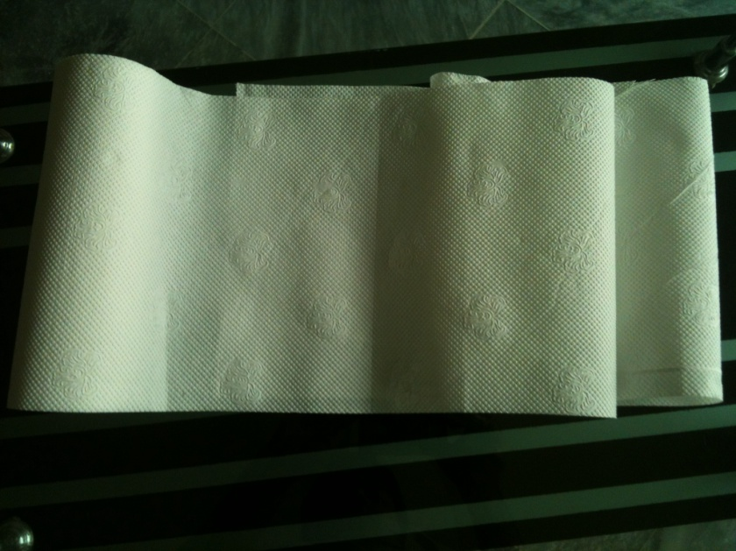

## Overview of Tissue Paper products

There are very few competing brands in the industry that are making the same kind of product. Silk will display design flexibility and manufacture customized product for large institutional buyers. Competitors also have the same product line but the depth and width vary from competitor to competitor.

# Pricing Strategy

Price is the most important ‘P’ of marketing mix because it brings revenue to the organization. Customer makes decision on the basis of price. Silk will follow skimming pricing strategy means first we will set high prices to minimize our payback period and to recover our costs before competition sets in. Keeping this in mind we are introducing our product with profit margin of 70% so our introductory price will be Rs. 20.4/ pack of 4. Using skimming pricing strategy is best for introductory product because as soon as new product enters the market, new competitors begin to appear in market so it’s important to recover your costs as soon as possible and later own the price will be lowered to obtain more market share. Initially our product will be available only in a single packaging size of 4 Towels. In order to effectively design and implement any of the pricing strategies, a firm should have a thorough understanding of consumer’s pricing psychology, and should systematically approach to set, adapt change prices (Cachon & Swinney, 2008). Pricing strategies should incorporate internal cost, target market and competitive consideration. In later part product life cycle, we can give discounts to our customers or we can incorporate changes in packing according to demand of that time like we can include a pack of 2 towel tissues costing Rs. 10, a roll of towel tissues costing in the range of Rs. 50 to Rs. 75 and a pack of tissues costing in the range of Rs. 100 to Rs. 150. It solely depends on time and conditions of that time.

## Distribution Strategy

### Channels

The sales will be done by following the channel shown below. Silk will use the following channel for distribution for its towel paper products. The towel tissues will be manufactured by the producer and then they will be distributed by the help of different distributors who are active in the market to different retailers in the markets. And then from the retailers they will reach the customers that are the eventual target of the sales.

Figure 1: Channels

## Promotional Strategy

A promotion plan describes the tools or tactics used to accomplish our marketing objectives. The promotional activities will be conducted to create awareness in customers regarding the new product we are launching. The basic objectives of promotion are to

* Increase sales
* Increase market share
* Build brand loyalty
* Build product differentiation in consumer’s mind

These objectives are achieved by successful marketing of product and captivating the trust of customers. Silk can use promotions in order to inform the customers, which is the basic motive of Silk at the moment. After it manages to develop awareness among the customers, which are the target segment of Silk, it can further use promotional tools to pursue and then successfully modify the behavior of the customers. Silk can use the above mentioned promotional objectives to increase sales and build product differentiation in consumers mind.

|  |  |
| --- | --- |
| **Our marketing objective is to** | **Then tools or tactics used will be** |
| Create awareness of towel tissues products. | * Advertise on different platforms (platforms are discussed in Promotional Strategy section and their costs in financial section) * Distribute product samples to obstetricians * Conduct exhibitions |
| Increase sales of Towel Tissues | * Distribute free samples at famous hotels * Sponsor an event attended by travelers and sportsmen. * Ads on famous TV channels |

Table 3: Marketing Objectives

## Website

To promote our product we will use advance range of advertisement in the different areas as visual Live or recorded Coverage such as local cable channels, news paper (Awaz and Din), bill boards and online in the website [www.wix.com/sarakhurshid91/silktoweltissues](http://www.wix.com/sarakhurshid91/silktoweltissues). This is further explained in promotion on electronic media section. As ‘Silk’ is starting its business in the tissue market so to reach the proposed customers and to win their faith in the product, it has to show its online presence and for that we have designed a user friendly website to tell them of our product. The website is consisting of simple and précised menu including information about the company and its business under the head of ‘Home’, the manufacturing procedures and processes under the head of ‘Manufacturing’, the marketing process under the head of ‘Marketing, and the advertising and promotional activities under the head of ‘Advertising and Promotion’.

The outlook of the designed website is given below:

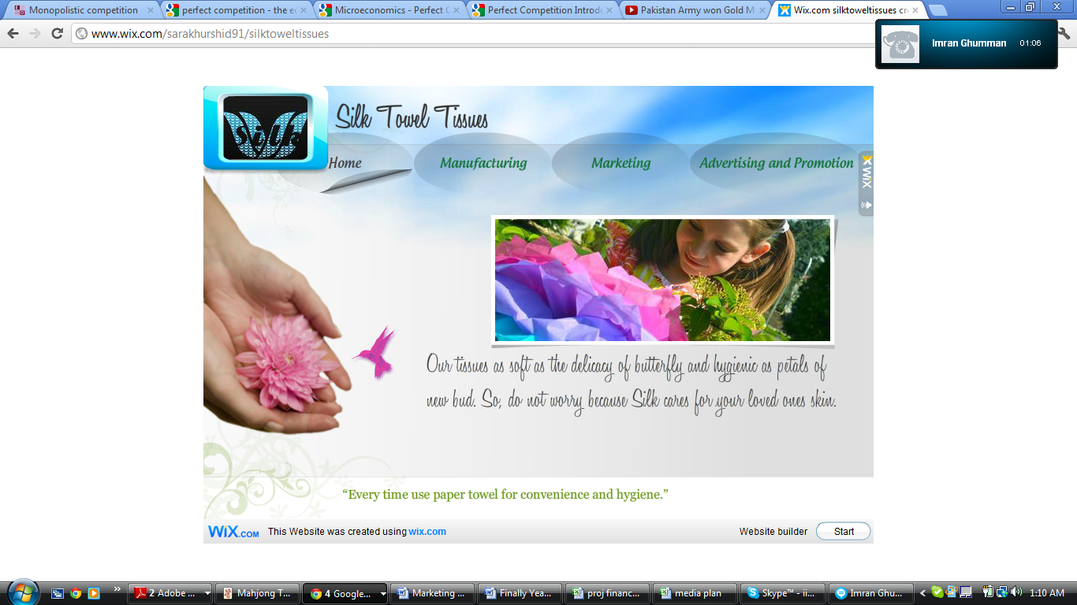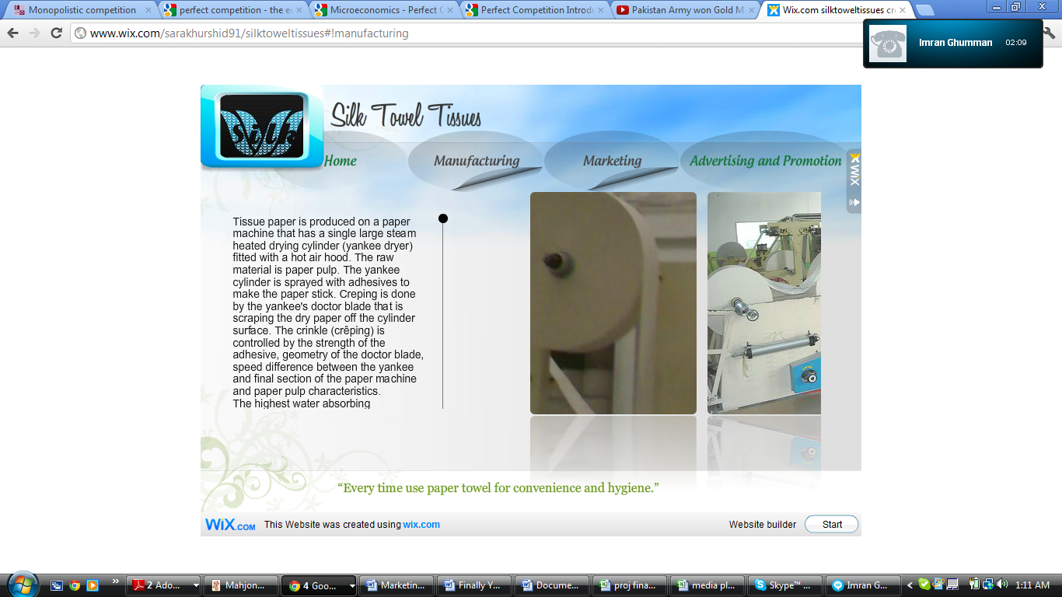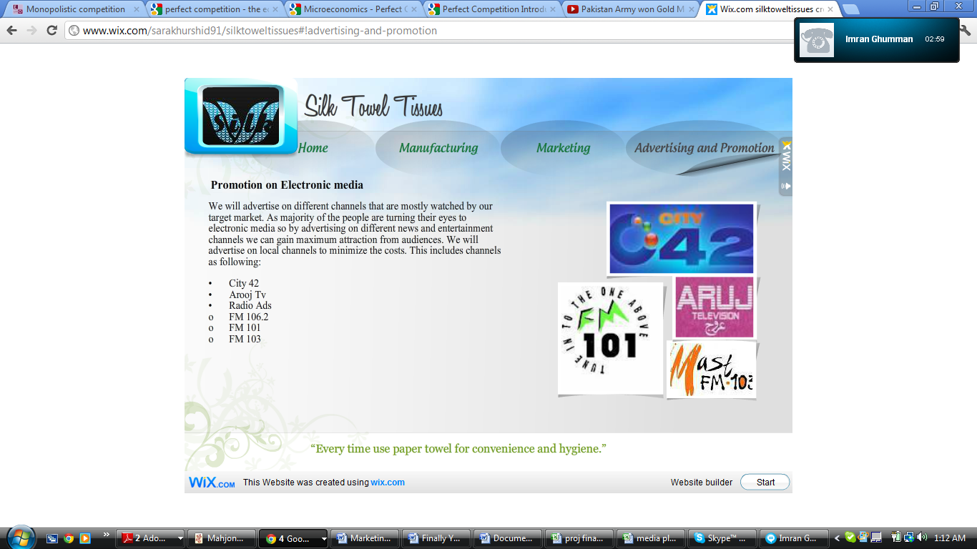

### Promotion on Electronic media

We will advertise on differentchannels that are mostly watched by our target market. As majority of the people are turning their eyes to electronic media so by advertising on different entertainment channels we can gain maximum attraction from audiences. We will advertise on local channels to minimize the costs. We will be using POS materials because eye catchy brochures and flexes are helpful because it’s by nature that whatever you see in this way, it always stay in back of your mind so when you see that product in market you are automatically attracted to that. The budget for the advertising is limited so the methods that will be used for the advertising are:

* Exhibitions
* Event Participation in Schools, Colleges and Universities
* Free Sampling (Educational Institutes and Companies)
* TVCs
* Print Ads
* Outdoor
* E-Marketing
* POS Material (Flexes and Brochures)

There are different strategies to reach out to the target customers for instance promotional activities in schools, colleges and universities. Placing stalls on exhibitions, concerts, movie premieres. BTL activation campaigns of other different local and multinational companies could also help us in reaching our proposed customers.

# Positioning

The positioning strategy for our product is benefit based positioning. Positioning strategy is developed in such a way to emphasize on unique and distinctive benefit. Our unique selling proposition is the benefits and value we are providing to our customers.

Our product has unique features that no other competitor is providing it’s the first of its kind product available in the market. The benefits that are most important are that it will replace the use of messy towels and will provide customers with an alternative.

## Tag line

“Every time use Silk towel tissues for convenience and hygiene.”

## Placement

Initially Lahore will be our focus and Towel tissues will be placed at main retail outlets and departmental stores as people are aware of silk towel tissue.

# Sales Plan

Creating a successful marketing strategy, finding opportunities to sell products and services, and connecting more effectively to current and prospective customers is very necessary when it comes to new product launch. Sales plan will help us towards developing a tactical marketing plan and sales process. For the awareness of the product, sales persons will be assigned with the duty of exploring the market and distributing the designed brochures in market. In this way the initial brand awareness step will be taken to penetrate into the market.

## Timeline

|  |  |
| --- | --- |
| **Activities** | **Duration** |
| **Research**   * **PEST & Porter 5 force analysis** * **Consumer behavior and business research towards the idea of towel tissue through questionnaires.** | 1 week |
| **Analysis of Findings** | 1 weeks |
| **Detail marketing plan (informal discussion on Collaboration Idea)** | 4 days |
| **Presentation marketing head** | 1 day |
| **Approval** | 1 week |
| **Implementation of plan** | 2week |
| **Promotional Activities** | 2 week |
| **Test Launch of Paper Towels in Lahore** | May 10, 2012 |

Table 4: Timeline

# Financial Plan

## Initial Funding

The initial funding required for the project in not very huge. The fixed assets will be a computer, some furniture and fixture. Rent of the office, utilities (Electricity, Gas, Water, and Internet etc), salaries of admin staff, delivery service, maintenance, transportation and advertising will be the fixed expenses. As we are getting our product from third party so we willer not have manufacturing costs. Main Startup expense includes:

|  |  |
| --- | --- |
| Computer | 30000 |
| Software | 30000 |
| Security | 10000 |
| Designing | 5000 |
| Furniture and Fixture | 30000 |
| Depreciation | 10000 |
| **Total** | **205000** |

Table 5: Initial Funding

The variable expenses that will be incurred monthly include

|  |  |
| --- | --- |
| Monthly Variable Expense |  |
| Towel Tissues and Printing | 700000 |
| Rent | 7000 |
| Bills (Electricity + Water) | 10000 |
| Internet + Telephone | 2000 |
| Maintenance | 1000 |
| Fuel | 20000 |
| Salaries | 30000 |
| Advertising Expenses | 350000 |
| Total | **1123000** |

Table 6: Variable Expense

## Expected Sales

* Number of Sales: 3,000 tissue packs
  + As we are considering daily purchase of around 100 packs it means total of 100*30= 3000
* Cost of Goods Sold (COGS): *Per Month:* 12*3,000= Rs. 36,000

*Per Year:* 36,000*12= Rs. 432,000

* Sales: *Per Month:* 20.4*3,000= Rs. 61,200 *Per Year:* 61,200*12= Rs. 734,400

As mentioned before, the numbers are based on assumptions (that initially we will have low sales but with increasing years the sales will increase. Our product will be distributed all over the country so on the whole we are considering the selling to be 100 per day). So we have assumed a sale of 3,000 packs of tissues per month. The cost which we have incurred per pack of tissues is Rs. 12 and the selling price for each pack will be Rs. 20 that will include in it the sales tax according to the government rules and regulations. The monthly cost and sales projections are given above.

## Breakeven Point

|  |  |
| --- | --- |
| **Fixed Expenses** |  |
| Computer | 30000 |
| Software | 30000 |
| Security | 100000 |
| Designing | 5000 |
| Furniture and Fixture | 30000 |
| Depreciation | 10000 |
| FC (Fixed Cost) | 205000 |
| **Variable Costs** | **Yearly** |
| Towel Tissues and Printing | 8400000 |
| Rent | 120000 |
| Bills (Electricity + Water) | 120000 |
| Internet + Telephone | 24000 |
| Maintenance | 12000 |
| Fuel | 240000 |
| Salaries | 360000 |
| Advertising Expenses | 4200000 |
| VC | 13476000 |
| VC per unit | 12 |
| **FC/(Sales price per unit-VC per unit)** | **25625 tissues** |

Table 7: Breakeven Point

The breakeven point is used to determine the point in units produced (and sold) where we will start making profit. It will be achieved at the sales of 25,625 units (packs) of towel tissues.

## Five year income statement:

|  |  |  |  |  |  |
| --- | --- | --- | --- | --- | --- |
|  | **Year 1** | **Year 2** | **Year 3** | **Year 4** | **Year 5** |
| Sales | 734400 | 807840 | 888624 | 977486 | 1075235 |
| COGS: Raw Material (tissues and printing) | 432000 | 475200 | 522720 | 574992 | 632491 |
| Designing | 3000 | 3000 | 3000 | 3000 | 3000 |
| **Gross Profit** | **299400** | **329640** | **362904** | **399494** | **439744** |
| Less: Expenses |  |  |  |  |  |
| Rent | 10000 | 10000 | 10000 | 10000 | 10000 |
| Utilities(Electricity & Water) | 120000 | 132000 | 145200 | 159720 | 175692 |
| Internet + Telephone | 24000 | 26400 | 29040 | 31944 | 35138.4 |
| Maintenance | 12000 | 13200 | 14520 | 15972 | 17569.2 |
| Fuel | 240000 | 264000 | 290400 | 319440 | 351384 |
| Salaries | 360000 | 396000 | 435600 | 479160 | 527076 |
| Advertising | 120000 | 660000 | 726000 | 798600 | 878460 |
| Others | 24000 | 26400 | 29040 | 31944 | 35138 |
| **Net Profit** | **-610600** | **898067** | **1316896** | **1447286** | **1590714** |

* The price of tissues will remain constant in coming years
* Cost of fuel will increase by 10% by keeping in mind current inflation rate of 11.10%
* Rent is given on 5 years contract basis so it will remain same
* The utilities like electricity, water, etc will cost 10% more in next year by keeping in mind current inflation rate of 11.10%
* Salaries and Maintenance cost will increase by 10% by keeping in mind current inflation rate of 11.10% (Trading Economics)
* Cost of advertising will increase by 10% but as initially we have to introduce our product so it requires more promotion but with maturity of product this advertising cost will decrease.
* Sales are expected to increase by 10% for 2 years then it will increase by 30% as product features will increase and brand will be recognized in market.

## Media Plan and Budget Allocation

As described before, the numbers are assumed. So in the allocation of budget the numbers are assumed and put according to the requirement against the media types which will be used for the advertising purpose. The selected media (TV, Newspapers, Outdoor, Internet, Radio, etc) and the budget allocated are described below with the detail of monthly and yearly budget allocation for advertising given separately.

|  |  |  |  |  |  |  |
| --- | --- | --- | --- | --- | --- | --- |
| **Monthly Budget Plan** | | | | | | |
| **MEDIA** | | **TOTAL** | | |  |  |
| TVCs | | 60000 | | |  |  |
| Print Ads | | 19000 | | |  |  |
| Outdoor | | 20000 | | |  |  |
| E-Marketing | | 6000 | | |  |  |
| POS Material | | 8000 | | |  |  |
| Radio | | 7000 | | |  |  |
| Total | | 100000 | | |  |  |
|  | |  | | |  |  |
|  | |  | | |  |  |
| Figure 3: Budget Advertising  **Yearly Budget** | | | |
| **MEDIA** | **TOTAL** | |  |
| TVCs | 720000 | |  |
| Print Ads | 228000 | |  |
| Outdoor | 240000 | |  |
| E-Marketing | 72000 | |  |
| POS Material | 96000 | |  |
| Radio | 84000 | |  |
| Total | 1440000 | |  |
|  |  | |  |

Figure 4: Yearly Budget

# CONCLUSION

With the implementation of all the above strategies we will be able to successfully launch our product in market. Our product has unique features that no other competitor is providing it’s the first of its kind product available in the market. The benefits that are most important are that it will replace the use of messy towels and will provide customers with an alternative.

# Bibliography

Ashfaq, M. W. (2011, 11 30). Marketing Department of Packages Limited. (M. Khan, Interviewer)

Islam, M. N. (2011, 12 1). Marketing Executive Packages Ltd. (R. Ghumman, Interviewer)

*List of Companies*. (n.d.). Retrieved December 1, 2011, from http://www.list-of-companies.org/Pakistan/Keywords/wet_tissue/

*tissue/markets/consumption_per_country*. (n.d.). Retrieved 12 2, 2011, from metsatissue.com: www.metsatissue.com/portal/metsa_tissue/markets/consumption_per_country

*Tissues-in-Pakistan*. (n.d.). Retrieved 11 1, 2011, from http://www.euromonitor.com/tissues-in-pakistan/report

*Trading Economics*. (n.d.). Retrieved from www.tradingeconomics.com/pakistan

# Appendix

**(1)**

## Questionnaire for Silk Towel Tissue

Q. 1. Do you like to use a towel in bath room?

* Yes
* No
* Other(please specify)________

Q.2. Do you believe multiple use of towel can spread diseases?

* Yes
* No
* Other(please specify) ________

Q.3. Would you prefer disposable hand towel tissue paper?

* Yes
* No
* Other(please specify) ________

Q.4. Would you like to use towel paper for house hold use (such in kitchen, guest room)?

* Yes
* No
* Other(please specify) ________

Q.5. Would you like to keep towel paper in pocket?

* Yes
* No
* Other(please specify) ________

Q.6. How much price would you like to pay for towel paper?

* Rs: 20
* Rs: 30
* Rs: 40
* Up to Rs: 40

Q.7. Are you health conscious?

* Yes
* No
* Other(please specify) ________

Q.8.What is your income level?

* Less than Rs. 10000
* Less than Rs. 20000
* Less than Rs. 30000
* More than Rs. 40000

Q.9. Is towel tissue represents social status?

* Yes
* No
* Other(please specify) ________

Q.10. Silk is good name for new towel tissue product?

* Yes
* No
* Other(please specify) ________

**(2)**

## Pie Charts for the responses to the questionnaires